PRODUCT LABEL PURSUANT TO CLAUSE 17.4 OF THE SEBI MASTER CIRCULAR SEBI/HO/IMD/IMD-PoD 1/P/CIR/2024/90 DATED JUNE 27, 2024

NAME OF THE SCHEME: CAPITALMIND FLEXI CAP FUND
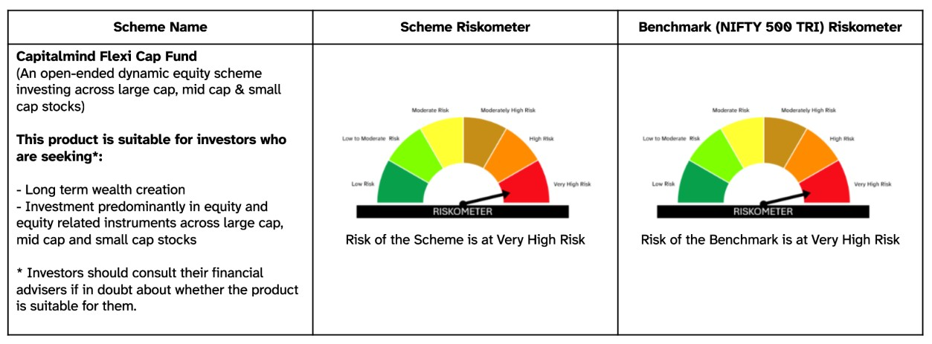

NAME OF THE SCHEME: CAPITALMIND LIQUID FUND
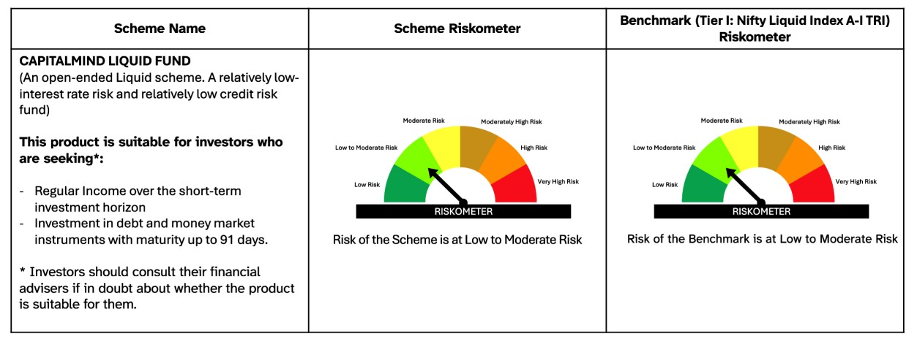

NAME OF THE SCHEME: CAPITALMIND MULTI ASSET ALLOCATION FUND
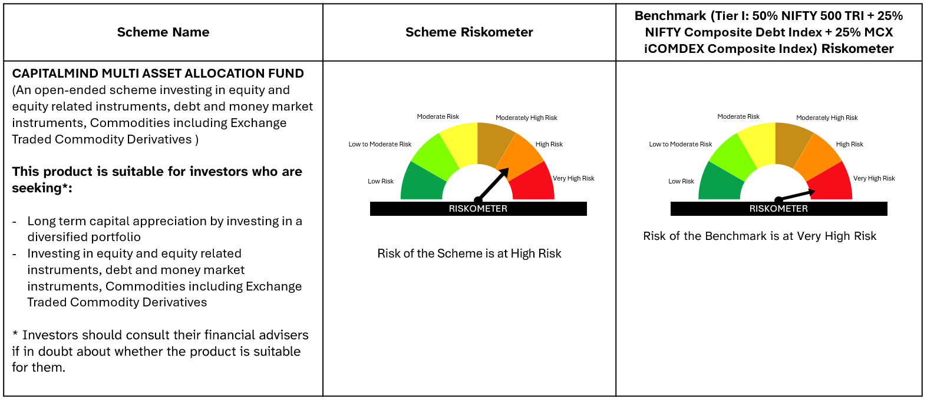

NAME OF THE SCHEME: CAPITALMIND ARBITRAGE FUND
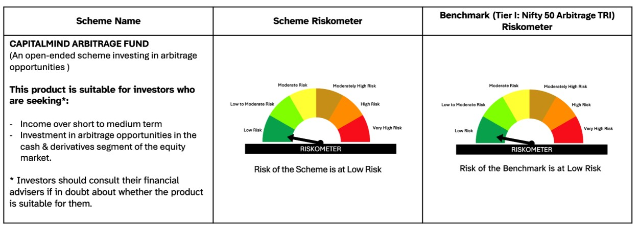

*Investors should consult their financial advisers if in doubt about whether the product is suitable for them #The product labelling is as on April 2026
The applicable Risk-o-meters will be reviewed monthly and notice about changes, if any, shall be issued. All other details of the Product Label and all other terms and conditions of the Scheme will remain unchanged.

MUTUAL FUND INVESTMENTS ARE SUBJECT TO MARKET RISKS, READ ALL SCHEME RELATED DOCUMENTS CAREFULLY

